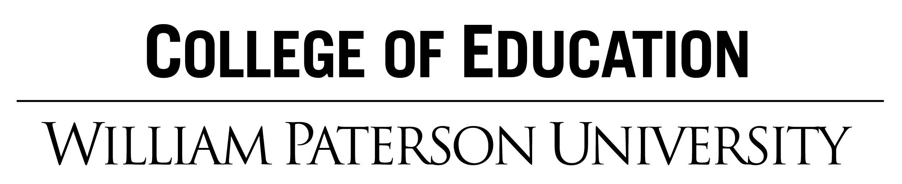

Candidate Name: Grade:
Topic: Date of Lesson:
NJSLS Standard(s):  WIDA Standards(s): |  | Content Objective(s): SWBAT  Language Objective(s): SWBAT |  | Assessment(s): (checklists, observation during student discussion, rubric evaluation, running records, observation notes, thumbs up/down, completed student work, observation during student activities, quizzes, tests, etc.)
 |  |  |  | College and Career Practices* (see below)
Academic Language/ Key Vocabulary
- Tier 1:
- Tier 2:
- Tier 3:
Planning:
- Materials (e.g. Props/Manipulatives):
- Technology / Visuals:
- Groupings:
- Family Engagement. (optional):
- Cite Sources (e.g. textbook page # or website)
Teaching and Learning
Motivation and activation of prior learning and knowledge (“Hook”):

Lesson Steps | Teacher  What questions will you ask? ( Bloom's Taxonomy)  What will you do, say, and/or write? |  | Students  What will students do? What tools will students use?  How will students be grouped?
Beginning
Middle
Closure
Differentiation of Instruction:
How will you differentiate for
- Process (instructional strategies that you use to allow access for all learners)
- Product (what students produce, assessments)
- Content (materials you alter to accommodate learning differences)

*12 College and Career Practices
CRP1. Act as a responsible and contributing citizen and employee.
CRP2. Apply appropriate academic and technical skills.
CRP3. Attend to personal health and financial well-being.
CRP4. Communicate clearly and effectively and with reason.
CRP5. Consider the environmental, social and economic impacts of decisions.
CRP6. Demonstrate creativity and innovation.
CRP7. Employ valid and reliable research strategies.
CRP8. Utilize critical thinking to make sense of problems and persevere in solving them.
CRP9. Model integrity, ethical leadership and effective management.
CRP10. Plan education and career paths aligned to personal goals.
CRP11. Use technology to enhance productivity.
CRP12. Work productively in teams while using cultural global competence.

